Final Project Report

Part A – Data Construction:

Discuss advice 2:

We’ll have divide-by-zero problem in normalizing the columns. The zero columns are generated because if p is small, the probability of not choosing non-zeros is high since each atom image is sparse. Since all algorithms will choose sparse solutions, the zero columns will not cause a problem in terms of choosing the optimal support.

Show two clean images and their corresponding noisy and corrupted versions



Part B – Inpainting by the Oracle Estimator

Insert average PSNR result of the Oracle estimator: 42.967

Show clean, noisy, corrupted and Oracle-based reconstruction:



Part C – Inpainting by Greedy Pursuit

Insert average PSNR result of OMP: 34.694

Show clean, noisy, corrupted and OMP-based reconstruction:

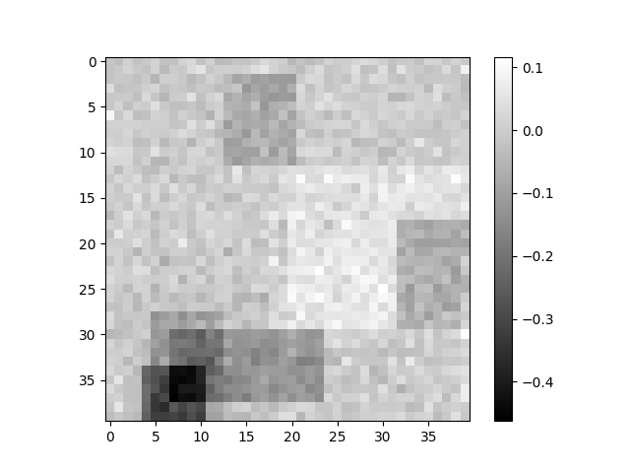

Compare between Oracle and OMP reconstructions:



Discuss results of OMP and compare to Oracle performance:

OMP result is not as good as the oracle result. But OMP can give a decent sparse solution efficiently. In this case, OMP’s solution gives the correct cardinality of supports, but makes mistake in choosing atoms and computing coefficients.

Show average PSNR of OMP as a function of $k$



Discussion regarding the average PSNR as a function of $k$:

In this case OMP chooses the correct support cardinality. However, notice k = 12 also gives a close second highest PSNR, so OMP can choose this in other cases. The reason is that in presence of noise, small change in support cardinality MAY give a slightly better result. A possible solution is to run experiment several times using different random seed and choose THE cardinality which has more votes.

If sigma is increased, OMP can choose a very different set of atoms, or in extremity, the zero solution as suggested in the textbook.

Part D – Inpainting by Basis Pursuit

Insert average PSNR result of Basis-Pursuit: 34.54167447059556

Show clean, noisy, corrupted and BP-based reconstruction:

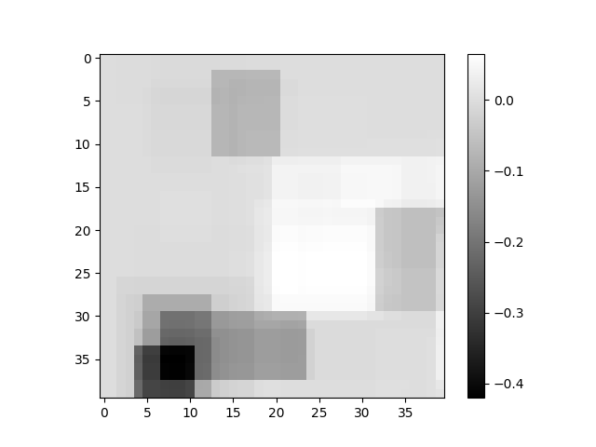



Compare between Oracle and OMP and BP reconstructions:

Discuss results of BP and compare to greedy methods and to the oracle performance:

BP gives a better result in this case. Although OMP has a slightly higher PSNR, it gives a denser solution compared with BP’s result. Visually BP’s result is closer to the oracle solution.

Show PSNR as a function of $λ$:



Discuss how $λ$ affects BP reconstruction:

Either too small or too large lambda is can end in suboptimal PSNR, but large lambda will put too much weight on sparsity regardless of data fidelity so it is worse.

For all images the best lambda is always the seventh one. Since all experiments share statistical feature of images and noise, as best lambda mainly depends on STD of non-zeros and STD of noise, a consistence choice of lambda is reasonable.

Part E – Effect of Parameters

Show MSE as a function of $p$ and $σ$:



Discuss the effect of $p$:

As p increases, the corruption lowers down, so OMP can find a closer reconstruction.

Discuss the effect of $σ$:

Change of sigma seems have negligible effect on OMP, indicating robustness of OMP.